Developing GUI for the project

Have created logo yelp Analytics

With home which contains information about analytics details are to be displayed

Code:

Index.jsp:

<%@ page language=*"java"* contentType=*"text/html; charset=UTF-8"*

pageEncoding=*"UTF-8"*%>

<!DOCTYPE html PUBLIC "-//W3C//DTD HTML 4.01 Transitional//EN" "http://www.w3.org/TR/html4/loose.dtd">

<html>

<head>

<style>

**body**{

margin: *0px*;

border: *0px*;

}

*.button* {

background-color:*#cc3300*;

border: *none*;

color: *white*;

padding: *15px 32px*;

text-align: *center*;

text-decoration: *none*;

display: *inline-block*;

font-size: *16px*;

text-color: *white*;

margin: *4px 2px*;

cursor: *pointer*;

}

*#navbar*{

background-color:*black*;

color: *white*;

}

**ul** {

margin:*0px*;

padding:*0px*;

width: *100%*;

height: *70px*;

list-style-type: *none*;

margin: *0*;

padding: *0*;

overflow: *hidden*;

background-color: *#cc3300*;

position:*fixed*;

top: *0*;

}

**ul** **li** {

float: *right*;

width:*100px*;

height: *80px*;

background-color: *black*;

opacity: *.8*;

line-height: *40px*;

text-align:*center*;

font-size: *20px*;

}

**ul** **li** **a** {

display: *block*;

color: *white*;

text-align: *center*;

padding: *14px 16px*;

text-decoration: *none*;

}

**ul** **li** **a***:hover:not*(*.active*) {

background-color: *#333* ;

}

**ul** **li** **ul** **li**{

display:*none*;

}

**ul** **li***:hover* **ul** **li**{

display:*block*;

}

*.active* {

background-color: *#333*;

}

*#container*

{

width:*100%*;

height:*100vh*;

}

*#container* **div**

{

position: *relative*;

width: *100%*;

height: *100%*;

}

</style>

</head>

<body>

<div id=*"navbar"*>

<ul>

<image src = *logo.jpeg*></image>

<li><a href=*"#contact"*>Contact</a></li>

<li><a href=*"about.jsp"*>About</a></li>

<li><a class=*"active"* href=*"#home"*>Home</a></li>

</ul>

</div>

<br>

<br>

<br>

<br>

<h1>Analytics on the yelp data</h1>

<ol><button class=*"button"*>1) Which day and which hour of the week a business will be busy</button></ol>

<ol><button class=*"button"*>2) How many more visitors are increased in weekends than week days</a></button></ol>

<ol><button class=*"button"*>3) Success based on location selection</a></button></ol>

<ol><button class=*"button"*>4) Success based on city selection</a></button></ol>

<ol><button class=*"button"*>5) Determine does attributes like wifi,bar along with restaurant attract more or not</a></button></ol>

</body>

</html>

Output:

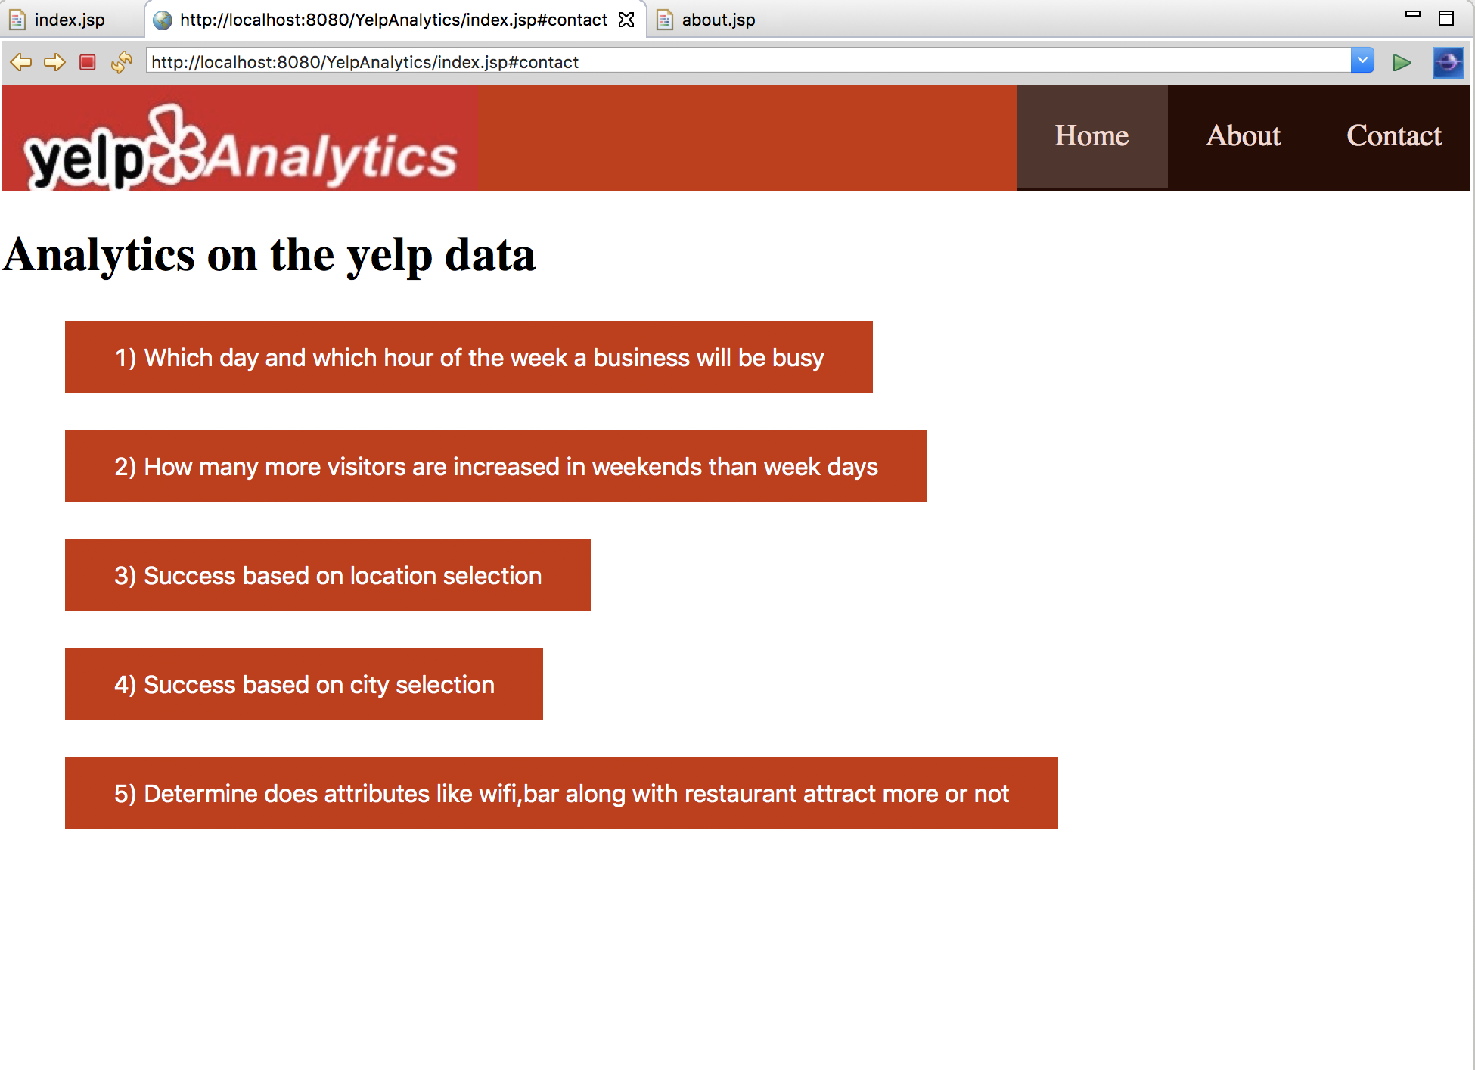

About.jsp:

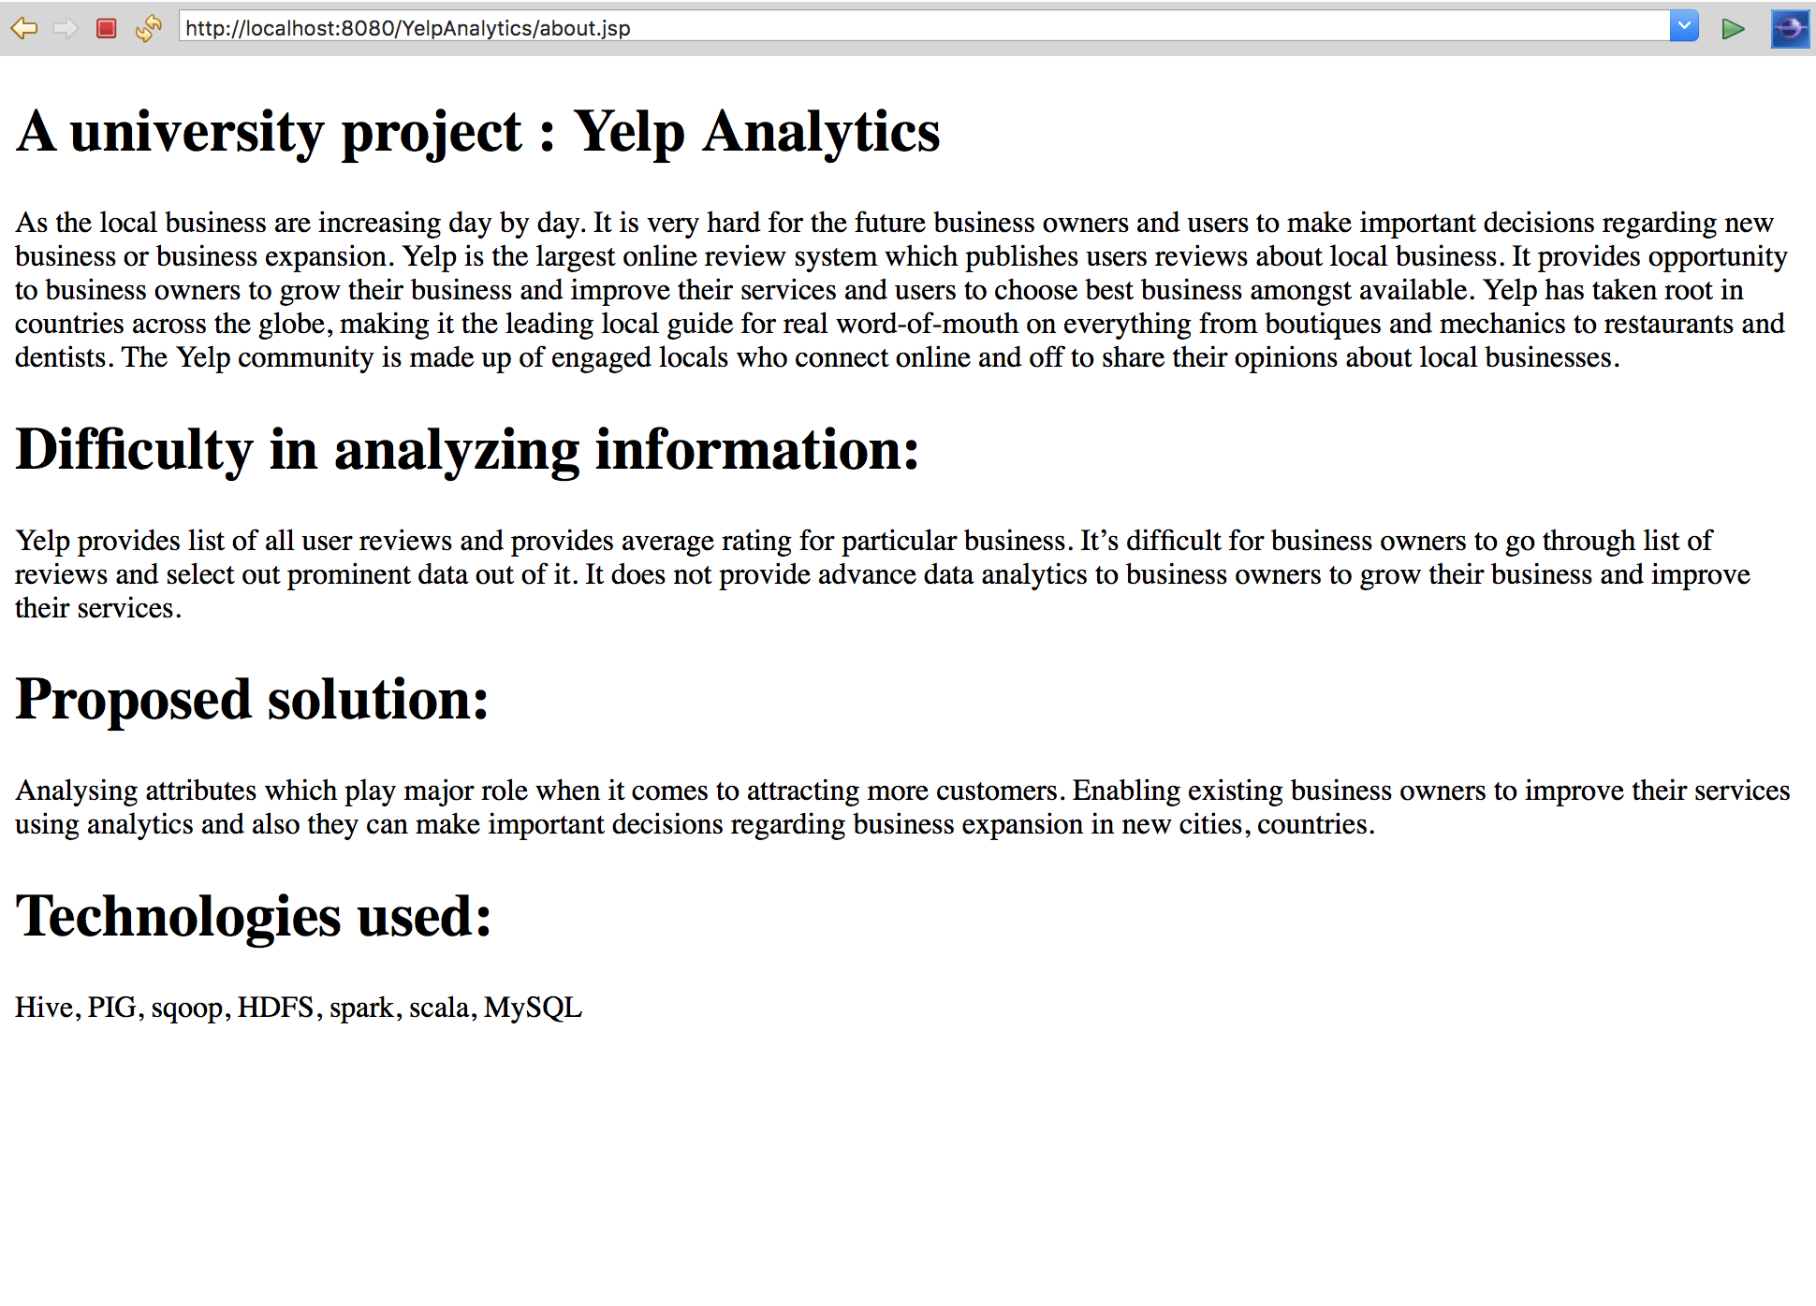

Task1.html:

<%@ page language="java" contentType="text/html; charset=UTF-8"

pageEncoding="UTF-8"%>

<!DOCTYPE html PUBLIC "-//W3C//DTD HTML 4.01 Transitional//EN" "http://www.w3.org/TR/html4/loose.dtd">

<html>

<head>

<style>

**body**{

margin: *0px*;

border: *0px*;

}

*.button* {

background-color:*#cc3300*;

border: *none*;

color: *white*;

padding: *15px 32px*;

text-align: *center*;

text-decoration: *none*;

display: *inline-block*;

font-size: *16px*;

text-color: *white*;

margin: *4px 2px*;

cursor: *pointer*;

}

*#navbar*{

background-color:*black*;

color: *white*;

}

**ul** {

margin:*0px*;

padding:*0px*;

width: *100%*;

height: *70px*;

list-style-type: *none*;

margin: *0*;

padding: *0*;

overflow: *hidden*;

background-color: *#cc3300*;

position:*fixed*;

top: *0*;

}

**ul** **li** {

float: *right*;

width:*100px*;

height: *80px*;

background-color: *black*;

opacity: *.8*;

line-height: *40px*;

text-align:*center*;

font-size: *20px*;

}

**ul** **li** **a** {

display: *block*;

color: *white*;

text-align: *center*;

padding: *14px 16px*;

text-decoration: *none*;

}

**ul** **li** **a***:hover:not*(*.active*) {

background-color: *#333* ;

}

**ul** **li** **ul** **li**{

display:*none*;

}

**ul** **li***:hover* **ul** **li**{

display:*block*;

}

*.active* {

background-color: *#333*;

}

**li** **img** {

padding:*5px*;

border:*5px solid #cc3300*;

background-color:*#cc3300*;

}

*#container*

{

width:*100%*;

height:*100vh*;

}

*#container* **div**

{

position: *relative*;

width: *100%*;

height: *100%*;

}

</style>

</head>

<body>

<div id=*"navbar"*>

<ul>

<image src = *logo.jpeg*></image>

<li><a href=*"Contact.html"*>Contact</a></li>

<li><a href=*"about.jsp"*>About</a></li>

<li><a class=*"active"* href=*"index.jsp"*>Home</a></li>

</ul>

</div>

</body>

<br>

<br>

<br><br>

<h1><i>Task1 : Which day and which hour of the week a business will be busy</i></h1>

<table>

<tr><th>Description</th><th>Picture</th></tr>

<tr><td>education and arts category which displays which day and which hour will be busy</td>

<td><li><img src =*"t1_education and arts.png"* width=*700* height = *400*></li></td></tr>

<tr><td>groceries category which displays which day and which hour will be busy</td>

<td><li><img src =*"t1_groceries.png"* width=*700* height = *400*></li></td></tr>

<tr><td>restaurants category which displays which day and which hour will be busy</td>

<td><li><img src =*"t1_restaurants.png"* width=*700* height = *400*></li></td></tr>

<tr><td>sports category which displays which day and which hour will be busy</td>

<td><li><img src =*"t1_spors.png"* width=*700* height = *400*></li></td></tr>

<tr><td>wine and bar category which displays which day and which hour will be busy</td>

<td><li><img src =*"t1_yoga.png"* width=*700* height = *400*></li></td></tr>

</table>

</html> 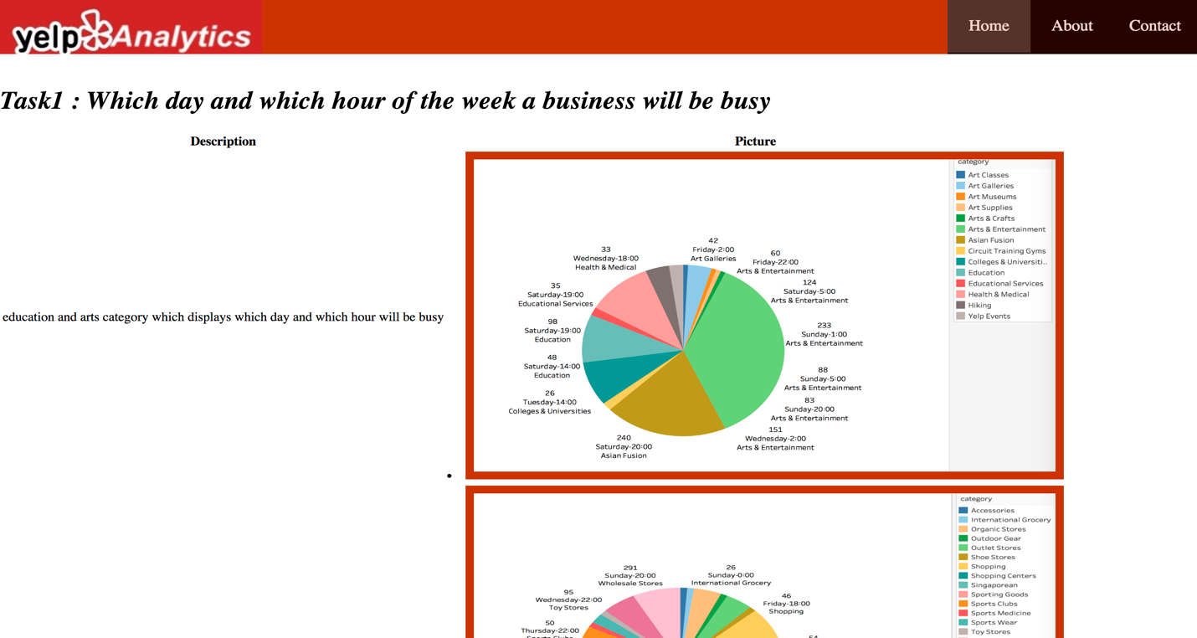

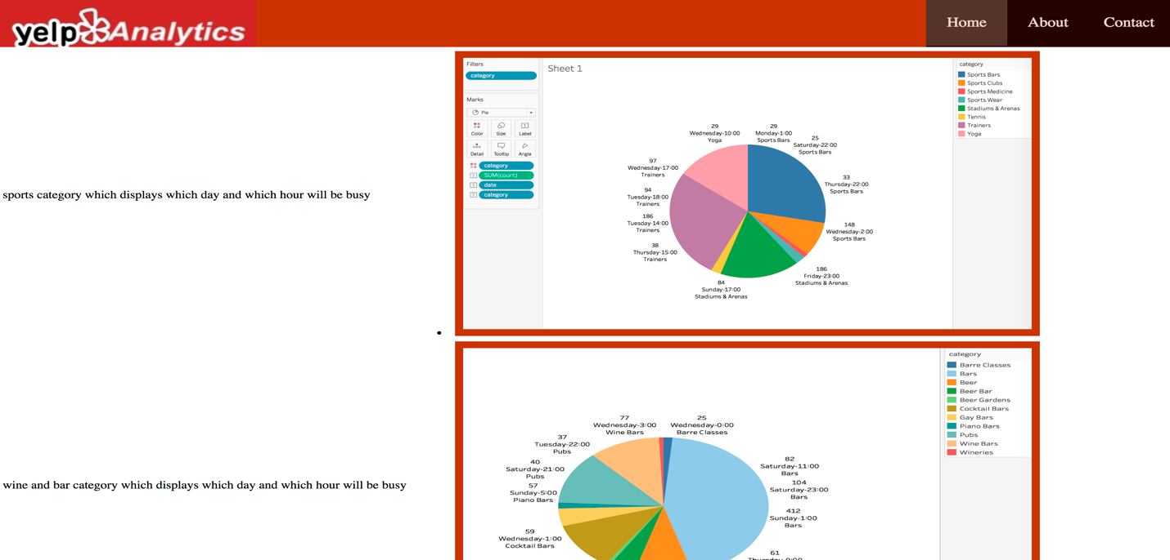

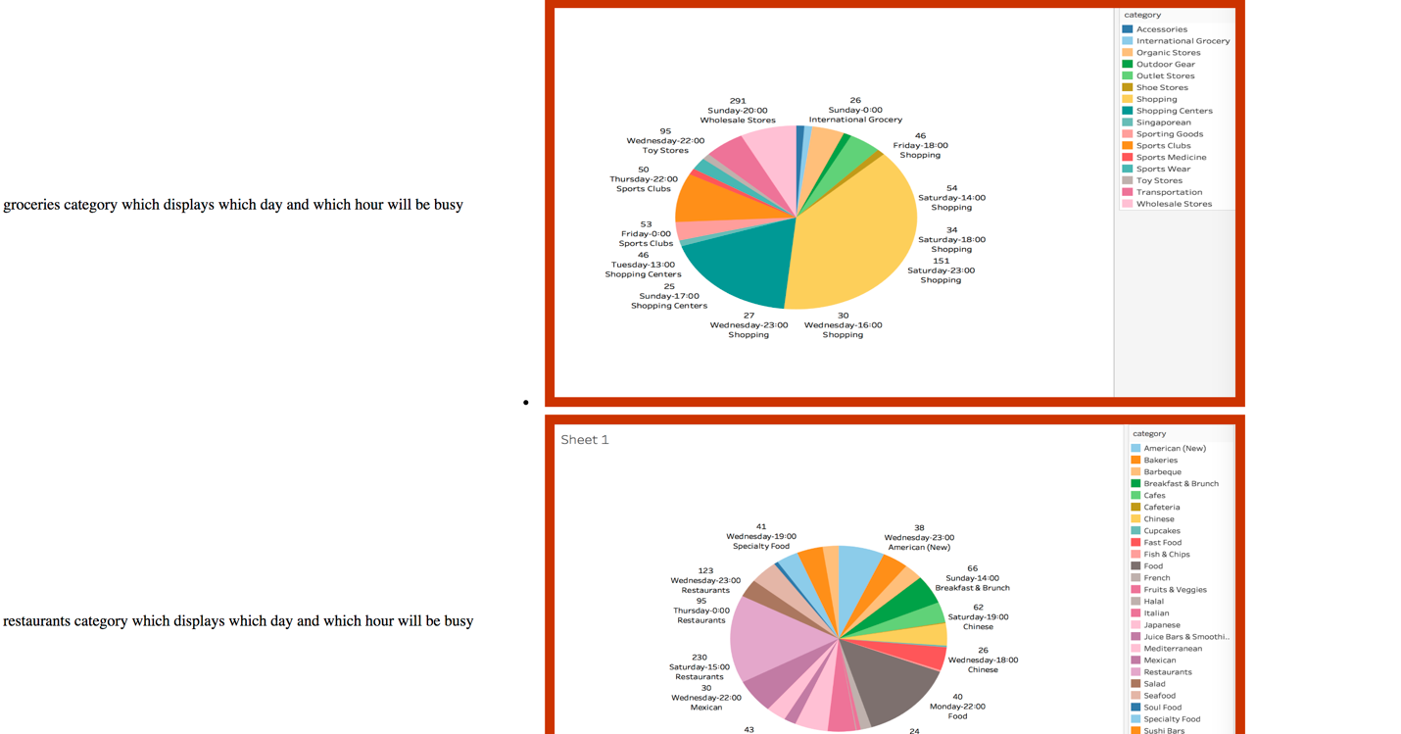

Task2.html:

<%@ page language="java" contentType="text/html; charset=UTF-8"

pageEncoding="UTF-8"%>

<!DOCTYPE html PUBLIC "-//W3C//DTD HTML 4.01 Transitional//EN" "http://www.w3.org/TR/html4/loose.dtd">

<html>

<head>

<style>

**body**{

margin: *0px*;

border: *0px*;

}

*.button* {

background-color:*#cc3300*;

border: *none*;

color: *white*;

padding: *15px 32px*;

text-align: *center*;

text-decoration: *none*;

display: *inline-block*;

font-size: *16px*;

text-color: *white*;

margin: *4px 2px*;

cursor: *pointer*;

}

*#navbar*{

background-color:*black*;

color: *white*;

}

**ul** {

margin:*0px*;

padding:*0px*;

width: *100%*;

height: *70px*;

list-style-type: *none*;

margin: *0*;

padding: *0*;

overflow: *hidden*;

background-color: *#cc3300*;

position:*fixed*;

top: *0*;

}

**ul** **li** {

float: *right*;

width:*100px*;

height: *80px*;

background-color: *black*;

opacity: *.8*;

line-height: *40px*;

text-align:*center*;

font-size: *20px*;

}

**ul** **li** **a** {

display: *block*;

color: *white*;

text-align: *center*;

padding: *14px 16px*;

text-decoration: *none*;

}

**ul** **li** **a***:hover:not*(*.active*) {

background-color: *#333* ;

}

**ul** **li** **ul** **li**{

display:*none*;

}

**ul** **li***:hover* **ul** **li**{

display:*block*;

}

*.active* {

background-color: *#333*;

}

**li** **img** {

padding:*5px*;

border:*5px solid #cc3300*;

background-color:*#cc3300*;

}

*#container*

{

width:*100%*;

height:*100vh*;

}

*#container* **div**

{

position: *relative*;

width: *100%*;

height: *100%*;

}

</style>

</head>

<body>

<div id=*"navbar"*>

<ul>

<image src = *logo.jpeg*></image>

<li><a href=*"Contact.html"*>Contact</a></li>

<li><a href=*"about.jsp"*>About</a></li>

<li><a class=*"active"* href=*"index.jsp"*>Home</a></li>

</ul>

</div>

</body>

<br>

<br>

<br><br>

<h1><i>Task2 : How many more visitors are increased in weekends than week days</i></h1>

<table>

<tr><th>Description</th><th>Picture</th></tr>

<tr><td>education and entertainment category that displays how many more visitors are increased in weekends than week day.</td>

<td><li><img src =*"t2_education and entertainment.png"* width=*700* height = *400*></li></td></tr>

<tr><td>adult category that displays how many more visitors are increased in weekends than week day.</td>

<td><li><img src =*"t2_adult.png"* width=*700* height = *400*></li></td></tr>

<tr><td>health category that displays how many more visitors are increased in weekends than week day.</td>

<td><li><img src =*"t2_health.png"* width=*700* height = *400*></li></td></tr>

<tr><td>nationality food category that displays how many more visitors are increased in weekends than week day in a pie chart.</td>

<td><li><img src =*"t2_nationality_food_pie.png"* width=*700* height = *400*></li></td></tr>

<tr><td>nationality food category that displays how many more visitors are increased in weekends than week day in a bar chart.</td>

<td><li><img src =*"t2_nationalityfood_bar.png"* width=*700* height = *400*></li></td></tr>

<tr><td>shopping and sports category that displays how many more visitors are increased in weekends than week day.</td>

<td><li><img src =*"t2_shopping and sports_pie.png"* width=*700* height = *400*></li></td></tr>

</table>

</html>

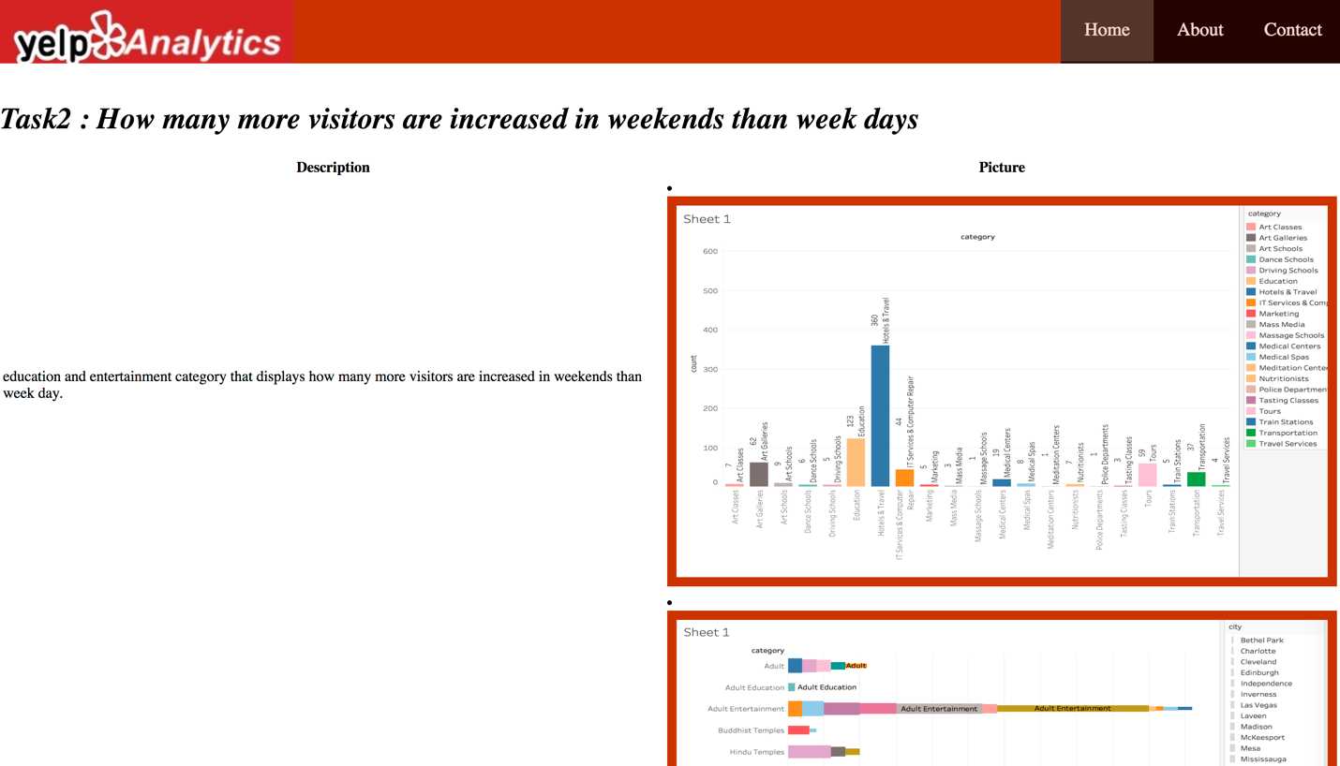

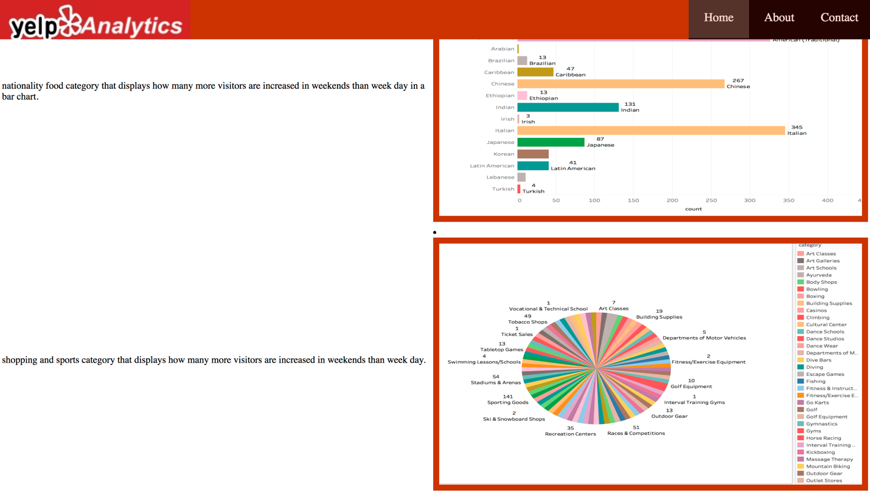

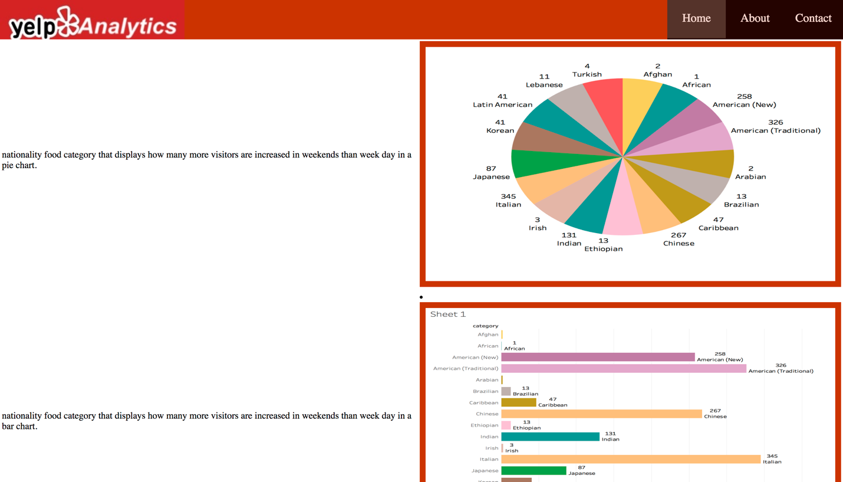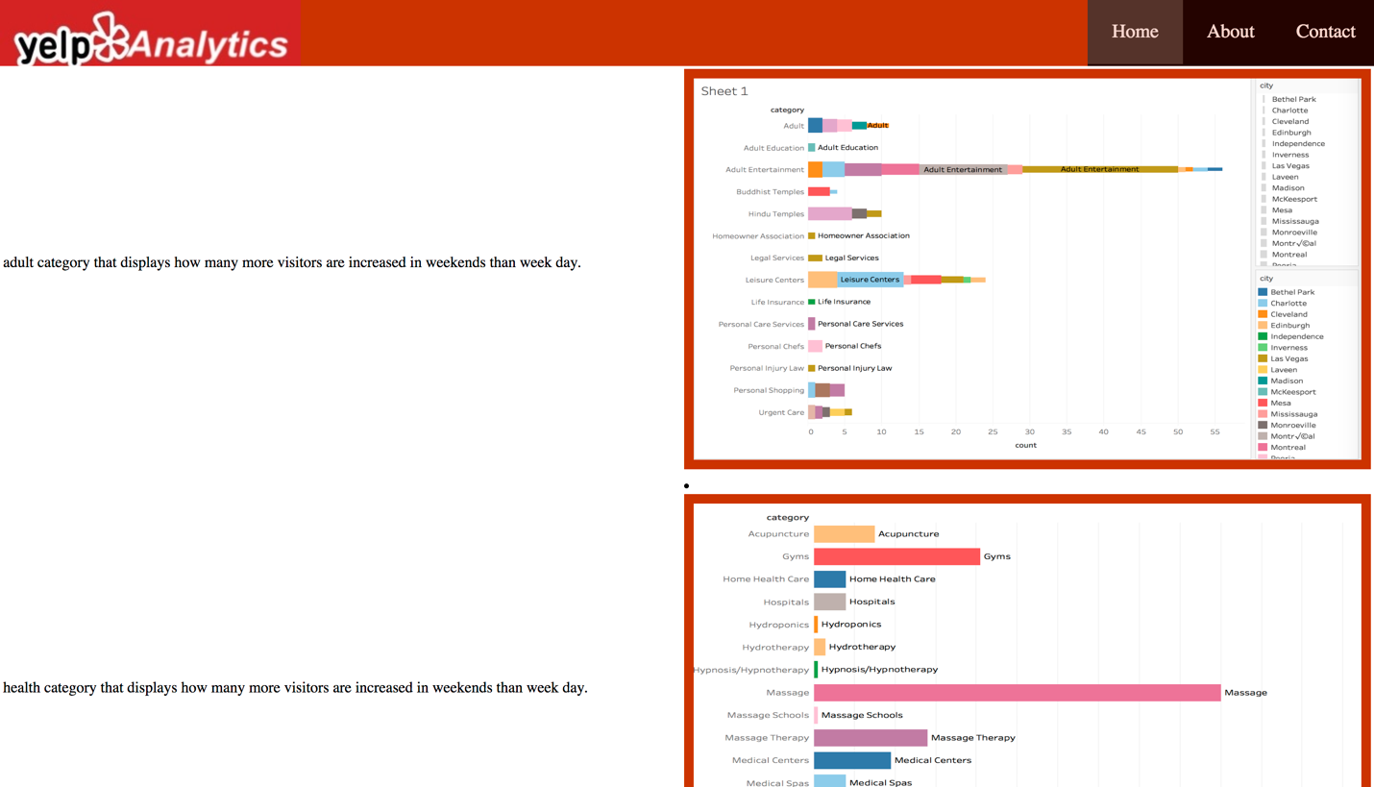

Task3: Success based on location selection

<%@ page language="java" contentType="text/html; charset=UTF-8"

pageEncoding="UTF-8"%>

<!DOCTYPE html PUBLIC "-//W3C//DTD HTML 4.01 Transitional//EN" "http://www.w3.org/TR/html4/loose.dtd">

<html>

<head>

<style>

**body**{

margin: *0px*;

border: *0px*;

}

*.button* {

background-color:*#cc3300*;

border: *none*;

color: *white*;

padding: *15px 32px*;

text-align: *center*;

text-decoration: *none*;

display: *inline-block*;

font-size: *16px*;

text-color: *white*;

margin: *4px 2px*;

cursor: *pointer*;

}

*#navbar*{

background-color:*black*;

color: *white*;

}

**ul** {

margin:*0px*;

padding:*0px*;

width: *100%*;

height: *70px*;

list-style-type: *none*;

margin: *0*;

padding: *0*;

overflow: *hidden*;

background-color: *#cc3300*;

position:*fixed*;

top: *0*;

}

**ul** **li** {

float: *right*;

width:*100px*;

height: *80px*;

background-color: *black*;

opacity: *.8*;

line-height: *40px*;

text-align:*center*;

font-size: *20px*;

}

**ul** **li** **a** {

display: *block*;

color: *white*;

text-align: *center*;

padding: *14px 16px*;

text-decoration: *none*;

}

**ul** **li** **a***:hover:not*(*.active*) {

background-color: *#333* ;

}

**ul** **li** **ul** **li**{

display:*none*;

}

**ul** **li***:hover* **ul** **li**{

display:*block*;

}

*.active* {

background-color: *#333*;

}

**li** **img** {

padding:*5px*;

border:*5px solid #cc3300*;

background-color:*#cc3300*;

}

*#container*

{

width:*100%*;

height:*100vh*;

}

*#container* **div**

{

position: *relative*;

width: *100%*;

height: *100%*;

}

</style>

</head>

<body>

<div id=*"navbar"*>

<ul>

<image src = *logo.jpeg*></image>

<li><a href=*"contact.html"*>Contact</a></li>

<li><a href=*"about.jsp"*>About</a></li>

<li><a class=*"active"* href=*"index.jsp"*>Home</a></li>

</ul>

</div>

</body>

<br>

<br>

<br><br>

<h1><i>Task3: Success based on location selection</i></h1>

<table>

<tr><th>Description</th><th>Picture</th></tr>

<tr><td>Success based on location selection</td>

<td><li><img src =*"t3_cities.png"* width=*700* height = *400*></li></td></tr>

</table>

</html>

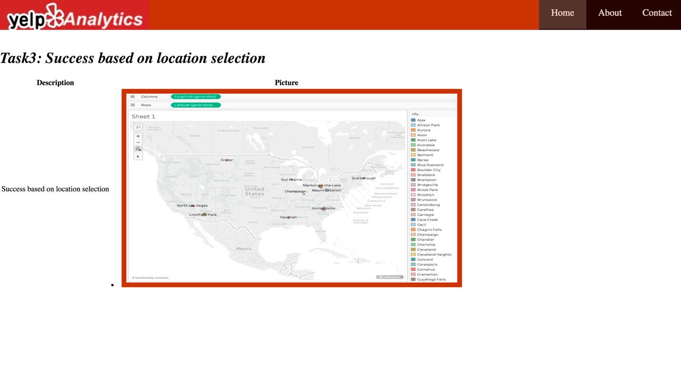

Task4.html:

<%@ page language="java" contentType="text/html; charset=UTF-8"

pageEncoding="UTF-8"%>

<!DOCTYPE html PUBLIC "-//W3C//DTD HTML 4.01 Transitional//EN" "http://www.w3.org/TR/html4/loose.dtd">

<html>

<head>

<style>

**body**{

margin: *0px*;

border: *0px*;

}

*.button* {

background-color:*#cc3300*;

border: *none*;

color: *white*;

padding: *15px 32px*;

text-align: *center*;

text-decoration: *none*;

display: *inline-block*;

font-size: *16px*;

text-color: *white*;

margin: *4px 2px*;

cursor: *pointer*;

}

*#navbar*{

background-color:*black*;

color: *white*;

}

**ul** {

margin:*0px*;

padding:*0px*;

width: *100%*;

height: *70px*;

list-style-type: *none*;

margin: *0*;

padding: *0*;

overflow: *hidden*;

background-color: *#cc3300*;

position:*fixed*;

top: *0*;

}

**ul** **li** {

float: *right*;

width:*100px*;

height: *80px*;

background-color: *black*;

opacity: *.8*;

line-height: *40px*;

text-align:*center*;

font-size: *20px*;

}

**ul** **li** **a** {

display: *block*;

color: *white*;

text-align: *center*;

padding: *14px 16px*;

text-decoration: *none*;

}

**ul** **li** **a***:hover:not*(*.active*) {

background-color: *#333* ;

}

**ul** **li** **ul** **li**{

display:*none*;

}

**ul** **li***:hover* **ul** **li**{

display:*block*;

}

*.active* {

background-color: *#333*;

}

**li** **img** {

padding:*5px*;

border:*5px solid #cc3300*;

background-color:*#cc3300*;

}

*#container*

{

width:*100%*;

height:*100vh*;

}

*#container* **div**

{

position: *relative*;

width: *100%*;

height: *100%*;

}

</style>

</head>

<body>

<div id=*"navbar"*>

<ul>

<image src = *logo.jpeg*></image>

<li><a href=*"Contact.html"*>Contact</a></li>

<li><a href=*"about.jsp"*>About</a></li>

<li><a class=*"active"* href=*"index.jsp"*>Home</a></li>

</ul>

</div>

</body>

<br>

<br>

<br><br>

<h1><i>Task4: Success based on city selection</i></h1>

<table>

<tr><th>Description</th><th>Analytics</th></tr>

<tr><td>Success based on city selection</td>

<td><li><img src =*"t4_bar.png"* width=*700* height = *400*></li></td></tr>

<tr><td>Success based on state selection</td>

<td><li><img src =*"t4_states.png"* width=*700* height = *400*></li></td></tr>

</table>

</html>

